ST. ERVAN PARISH COUNCIL
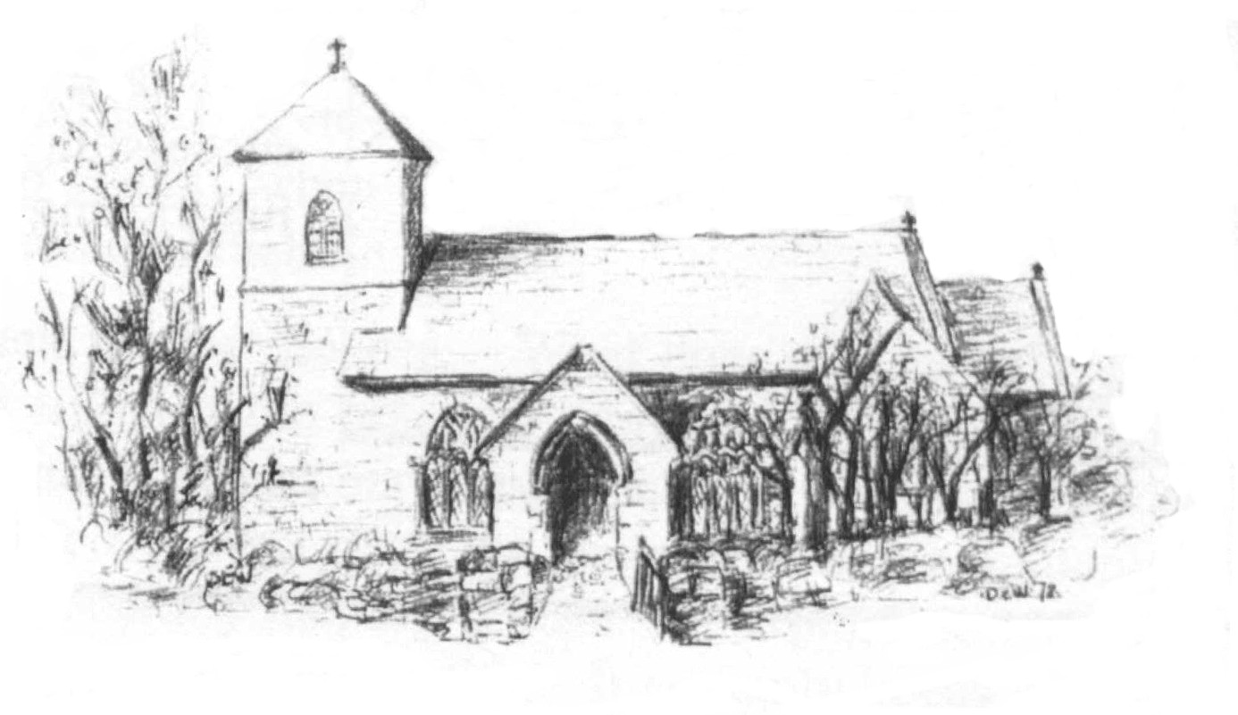
Jacqui Peskett
Parish Clerk
Tel 07835 937261
Email stervanpc@outlook.com

St Ervan Parish Council Meeting Minutes – Tuesday 5th March 2024 commencing 7.15pm.

Apologies: Cllr J Skinner and Cornwall Councillor Stephen Rushworth

Present: Cllrs R Biddick (Chair), J Eustice, M Biddick, R Kent, K Wood, L Clarke.

In Attendance: J Peskett (Clerk) and 10 members of the public.

55/24 Declarations of interest: None.

56/24 Public Participation: A number of Parishioners spoke in respect of Planning Application PA23/10324 – Bears Down Wind Farm. A representative from Clean Earth was also in attendance so able to answer questions.
Main concerns were:
- Size
- Noise
- Lighting
- Route used to transport to location
- Disruption to businesses and homes with loss of internet and telephone during transportation
- Distance to homes
- Life expectancy
- Who will benefit

57/24 Cornwall Councillor Report: Not in attendance.

58/24 St Ervan Parish Council Meeting 2nd January 2024: It was proposed by Cllr M Biddick seconded by Cllr R Kent and resolved that the minutes of the above meeting having been previously circulated, be accepted. All in favour, carried.

59/24 Matters arising: None

60/24 Planning Applications: to consider Planning Applications or any that may be received since the agenda was published:
Non Material Amendment (1) to Application No. PA22/07877 dated 21st December 2022 for Alterations to the external and internal space within a newly built light Industrial shed to create space for training, meeting, break out space, storage for vehicles, craft and equipment. Additional items include a new septic tank/interceptor and a new wash down area for hosing down equipment and vehicles, namely, to change new windows in the elevations from grey powder coated aluminium frames to white Upvc window frames
Planning Application
RNLI Former NAAFI 3 The Old Airfield St Merryn Padstow Cornwall PL28 8PU
Ref. No: PA24/0054 -considered by email and SUPPORTED 23rd February 2024
It was proposed by Cllr M Biddick, seconded by Cllr Kent to sanction this decision.

Proposed Repowering of Bears Down Wind Farm with five wind turbines and associated infrastructure including access tracks, electrical housing, underground cabling and temporary construction hardstanding areas.
Planning Application
Bears Down Wind Farm St Eval Wadebridge Cornwall PL27 7TA
Ref. No: PA23/10324 – considered and not unanimous decision. It was decided to “leave it on the table” with comments sent through to Cornwall Council.

61/24 Correspondence

- To receive the Police report (previously circulated) – noted
- Penrose Chapel – noted and discussed.

62/24 Highways To CONSIDER any issues that may have arisen and resolve appropriate action:
White Lines not retained at Rumford Cross Roads. Other issues reported throughout the Parish. Road issues – the Clerk will try and set up a meeting with a representative from Highways to come and view the problems.

63/24 Internal Audit 2024: To consider and approver an Internal Auditor for the end of year accounts: It was agreed that Mrs C Y May be appointed at a cost of £70 to undertake an internal audit.

64/24 Finance
Expenditure
Transaction | Nett | VAT | Paid
Clerk Salary (2 months) | £266.74 | £0.00 | £266.74
Clerk expenses (2months) | £51.25 | £0.00 | £51.25
HMRC/PAYE | £31.15 | £0.00 | £33.15
Duchy Defibrillators | £560.00 | £112.00 | £672.00
Duchy Defibrillators | £560.00 | £112.00 | £672.00

Income
Interest for 2 months | £10.01

Balances as at time of setting the Agenda.
Treasurers Account | £ 58.95
Business Instant Access Account | £2,951.86

It was proposed by Cllr M Biddick, seconded by Cllr Clarke and resolved that these are accepted and paid. All in favour – carried.

Items for information and take to the May meeting: None.

The Chairman closed the meeting at 7.50pm.

Date of Next Meeting Tuesday 7th May 2024 @7.30pm Signed…………………………………

